Backend API Development: Creating RESTful Services with AI
Name: V.Prapul Kumar
Rollno:2503a52377
Batch-13

Task 1: Setup FastAPI Backend

Prompt :
Create a basic FastAPI app with a root GET endpoint that returns a welcome message.

Code
from fastapi import FastAPI
app = FastAPI()
@app.get("/")
def read_root():
"""Return a welcome message."""
return {"message": "Welcome to AI-powered FastAPI"}

Output
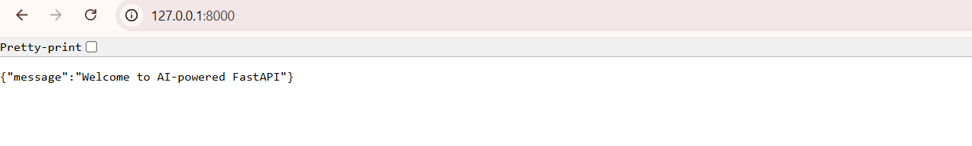

Justification
FastAPI creates the backend application. The GET endpoint at / returns a welcome message and confirms that the server is running.

Task 2: API – Create and Read Items

Prompt (Small)
Add GET and POST endpoints to retrieve and create items using a Python list.

Code
items = []
@app.get("/items")
def get_items():
"""Return all stored items."""
return items
@app.post("/items")
def add_item(item: dict):
"""Add an item to the list."""
items.append(item)
return {"message": "Item created", "item": item}

Output
GET /items :
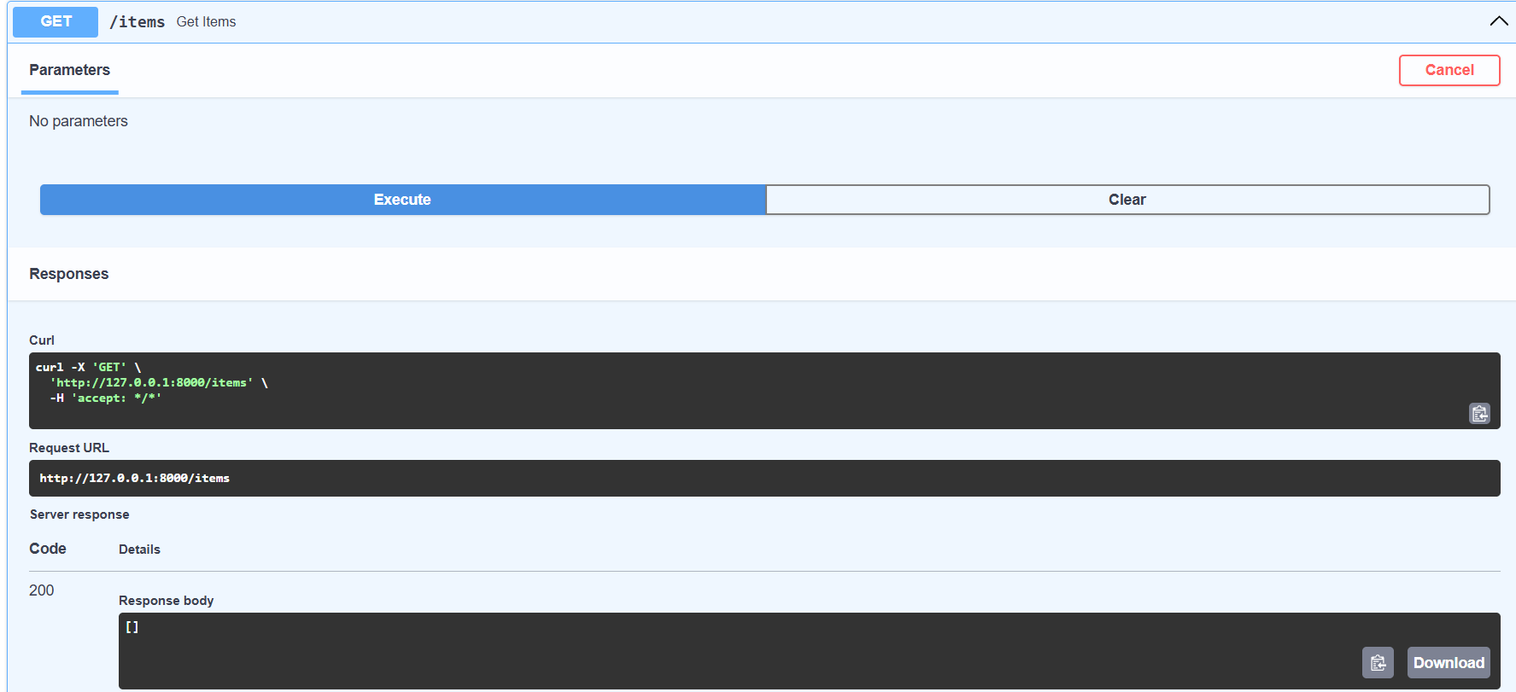
POST /items :
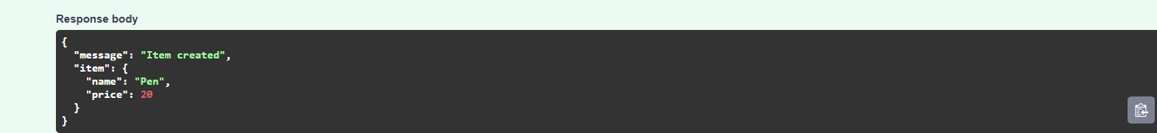
Justification
The GET endpoint displays the items in the list. The POST endpoint accepts an item as JSON, stores it in the list, and returns a confirmation message.

Task 3: Update Existing Item

Prompt (Small)
Create a PUT endpoint that updates an item by its zero-based index and reports when the item is not found.

Code
@app.put("/items/{index}")
def update_item(index: int, item: dict):
"""Update an item at the given index."""
if index < 0 or index >= len(items):
raise HTTPException(status_code=404, detail="Item not found")
items[index] = item
return {"message": "Item updated", "item": item}

Output
PUT /items:
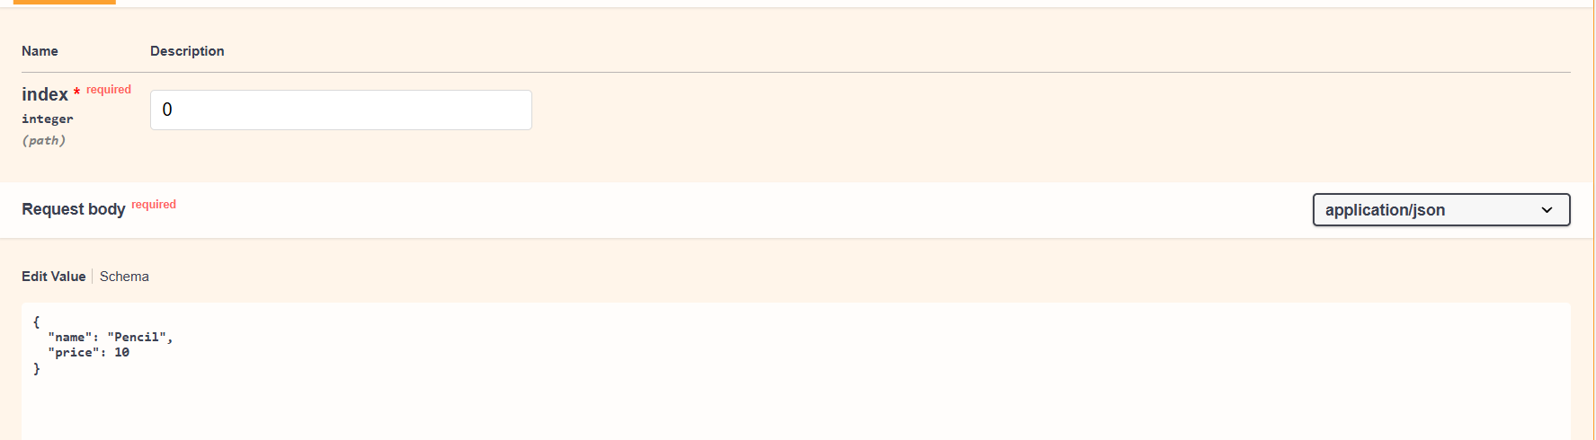
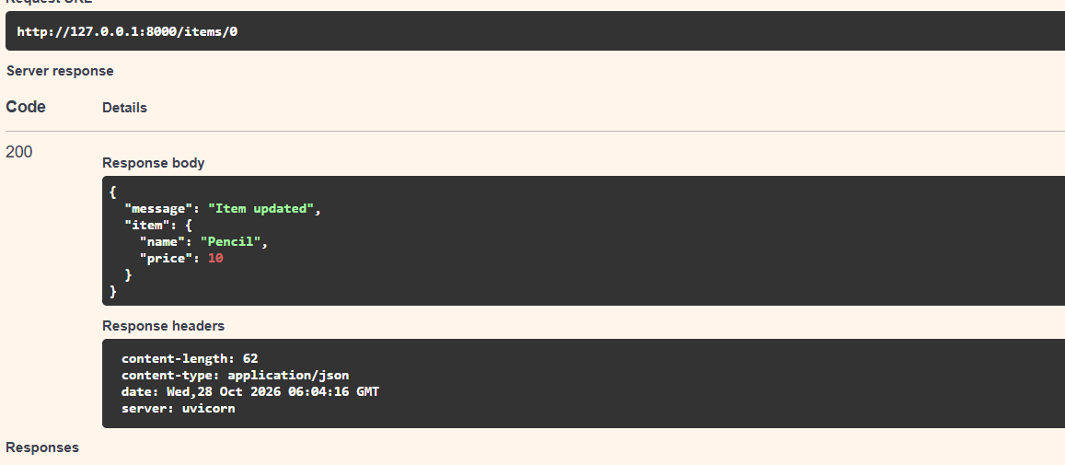

Justification
The PUT endpoint replaces the item at the specified index. It returns a 404 error if the index does not refer to an existing item.

Task 4: Delete Item

Prompt (Small)
Create a DELETE endpoint that removes an item by its index and returns the deleted item.

Code
@app.delete("/items/{index}")
def delete_item(index: int):
"""Delete an item at the given index."""
if index < 0 or index >= len(items):
raise HTTPException(status_code=404, detail="Item not found")
removed = items.pop(index)
return {"message": "Item removed", "item": removed}

Output
DELETE /items/0:
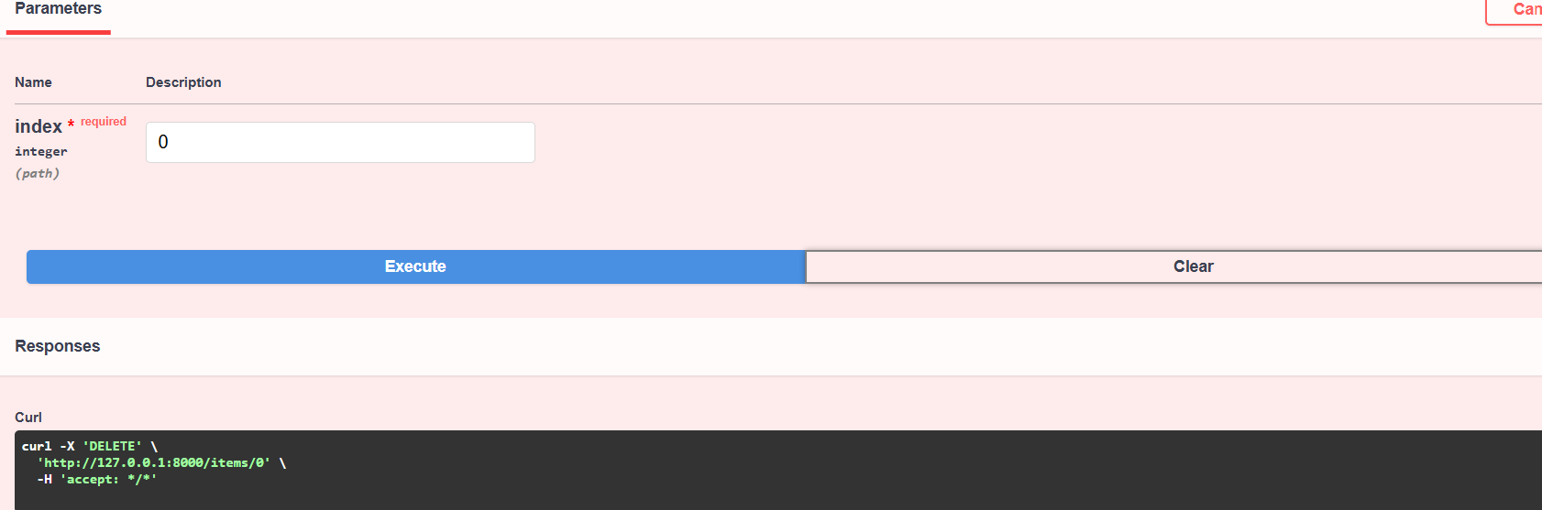
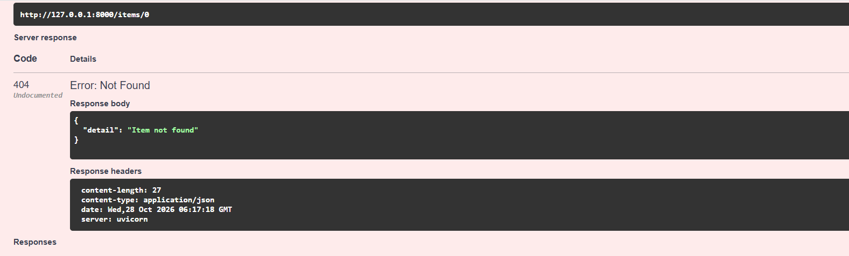

Justification
The DELETE endpoint removes the selected item from the list and returns the removed item. Invalid indexes produce a 404 error.

Task 5: Add Auto-Generated Documentation

Prompt (Small)
Add comments, docstrings, endpoint summaries, and Swagger documentation to the FastAPI endpoints.

Code
from fastapi import FastAPI, HTTPException
app = FastAPI(
title="Items CRUD API",
description="API for creating, reading, updating, and deleting items",
version="1.0.0"
)
@app.get("/items", summary="Get all items")
def get_items():
"""Return all items stored in memory."""
return items
@app.post("/items", summary="Create an item")
def add_item(item: dict):
"""Create and return a new item."""
items.append(item)
return {"message": "Item created", "item": item}
Add summaries and docstrings to the PUT and DELETE endpoints in the same way.

Output
Run the server and open:

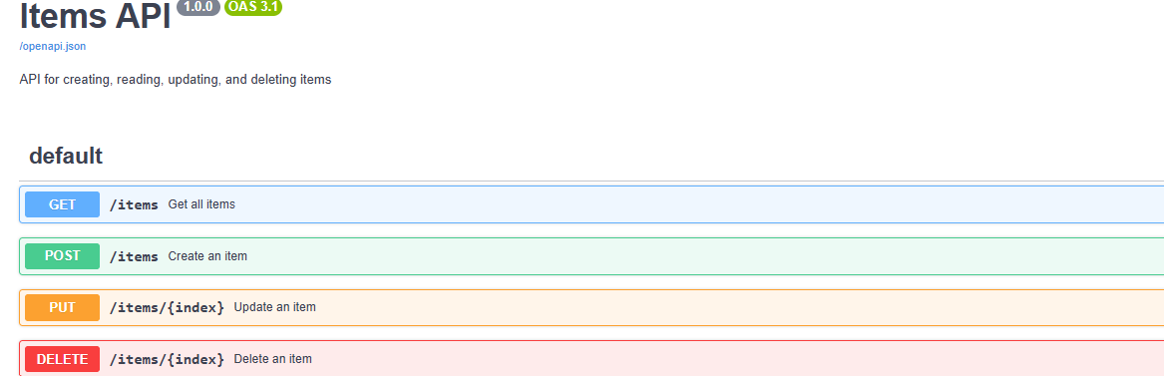
Swagger UI displays the available endpoints, HTTP methods, descriptions, and request body fields.

Justification
FastAPI reads endpoint definitions, type hints, summaries, and docstrings to generate interactive Swagger documentation automatically. The /docs page helps users test the API without needing a separate API client.

